1)
Code:
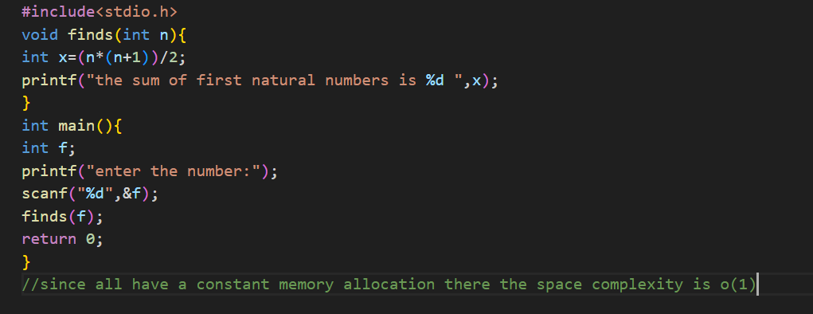
Output:
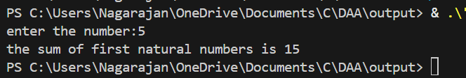
Justification:
Since there are all constant memory allocation the space complexity will be of O(1)
2)
Code:
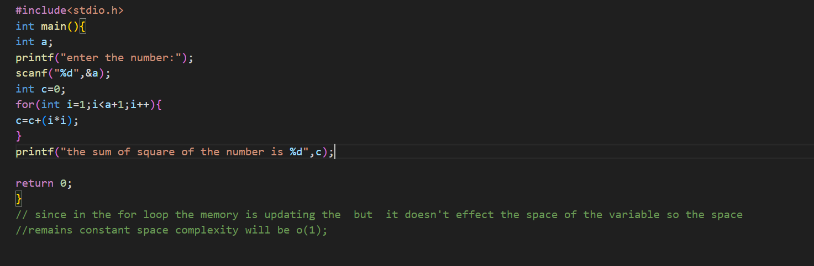
Output:
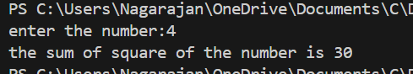
Justification :
There are totally two variable which are declared so the total memory will be of 8 bytes
Hence the memory is constant the space complexity will be of O(1)
3)
Code:
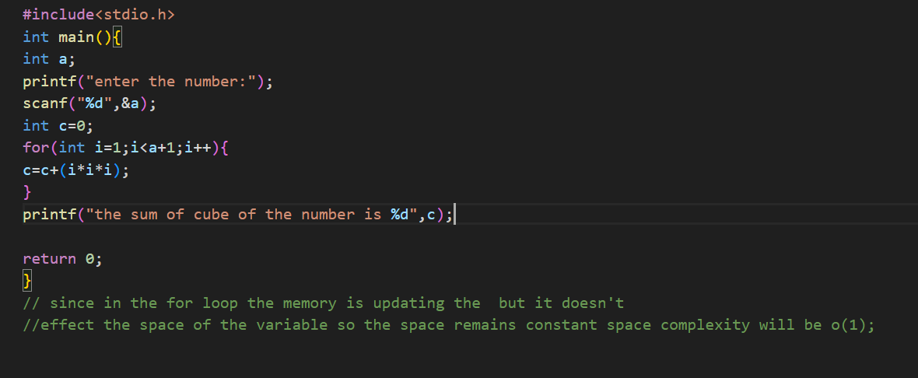
Output:
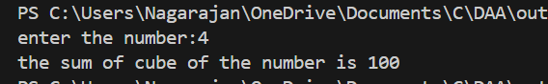
Justification:
Here also the same case there are only two variable allocated and the loop doesn’t consider because we are considering the memory the loop won’t increase the memory so the memory is constant so the space complexity is O(1)
4)
Code:
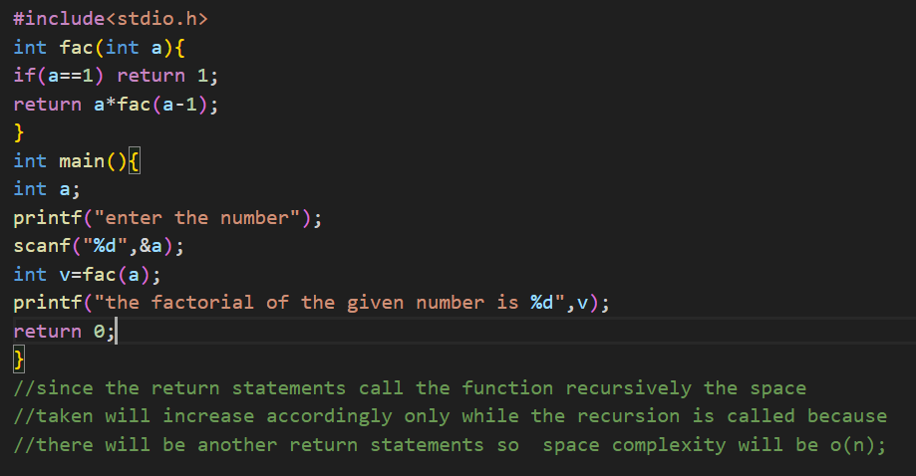
Output:
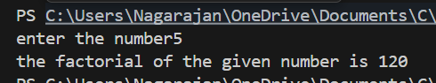
Justification:
Here there is recursion so return take some memory.
Now we consider the return memory takes 1 unit of memory
So now in the base case the return consist of 1 unit of memory
And in the recursive case there is an recursion so there will be multiple times of returning which will cost memory
So, If the recursion take n steps then the memory will also be n
So the space complexity will be O(n)
5)
Code:
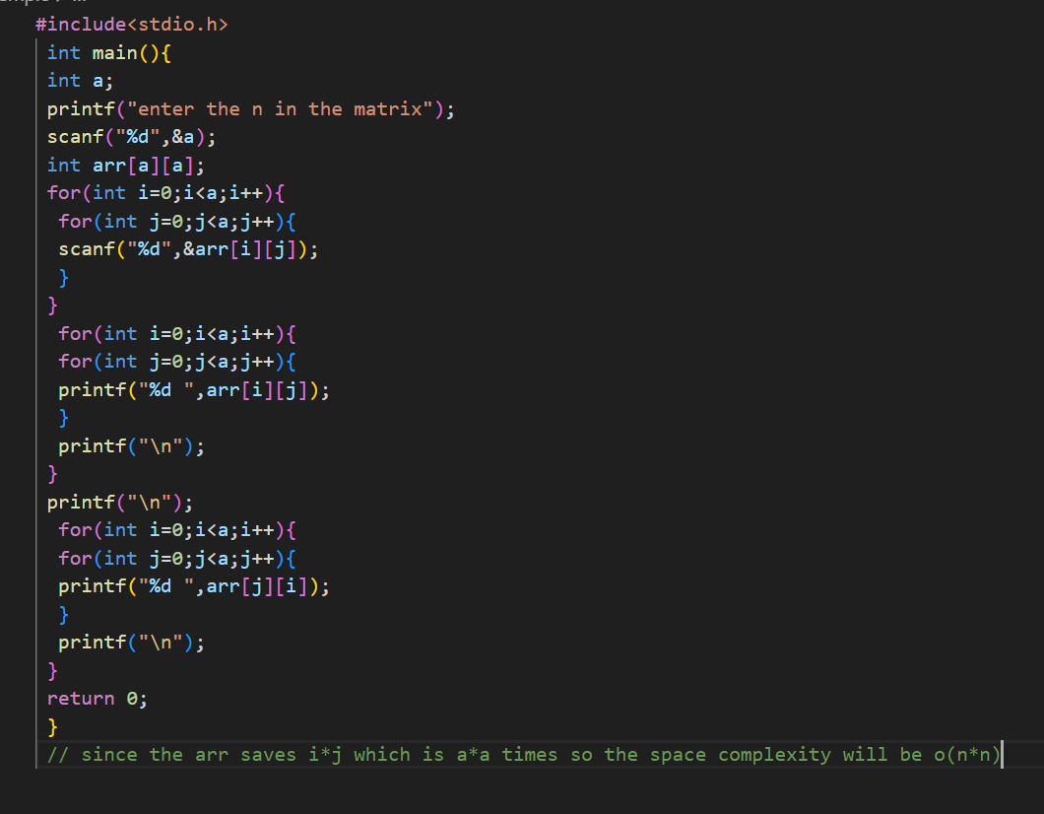
Output:
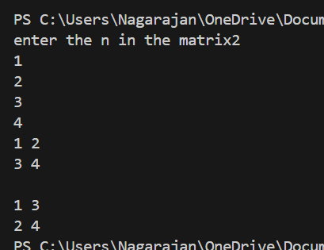
Justification:
Here we are allocation a matrix, an 2d array and we are not pre including the size of the array so in this case like int arr[n][m]
The space takes O(m*n)
But in our case we have used int arr[n][n]
So the space complexity will be O(n*n)
And if the matrix is already given then the space taken will be constant the there will O(n)
6)
Code:
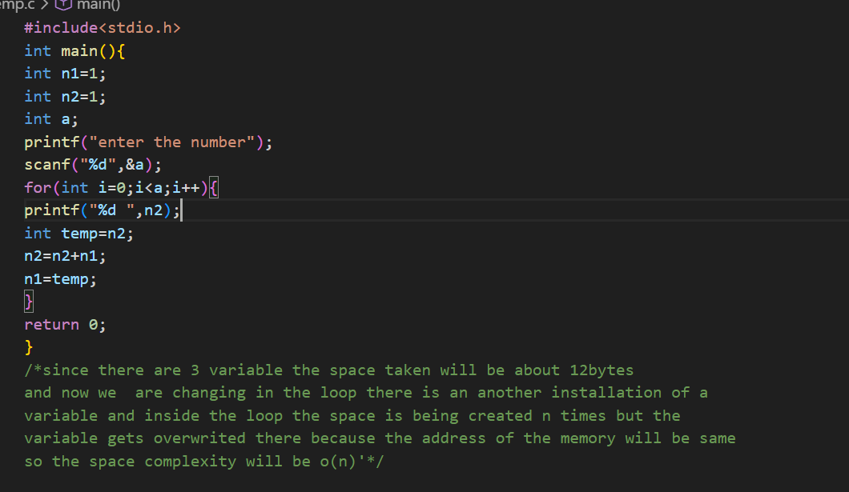
Output:
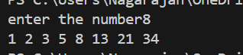
Justification:
Here we have totally 3 variable and one is inside the loop so every time it is initializing but the memory address will be same every time so there will be a constant memory again so the space complexity will be O(n)

